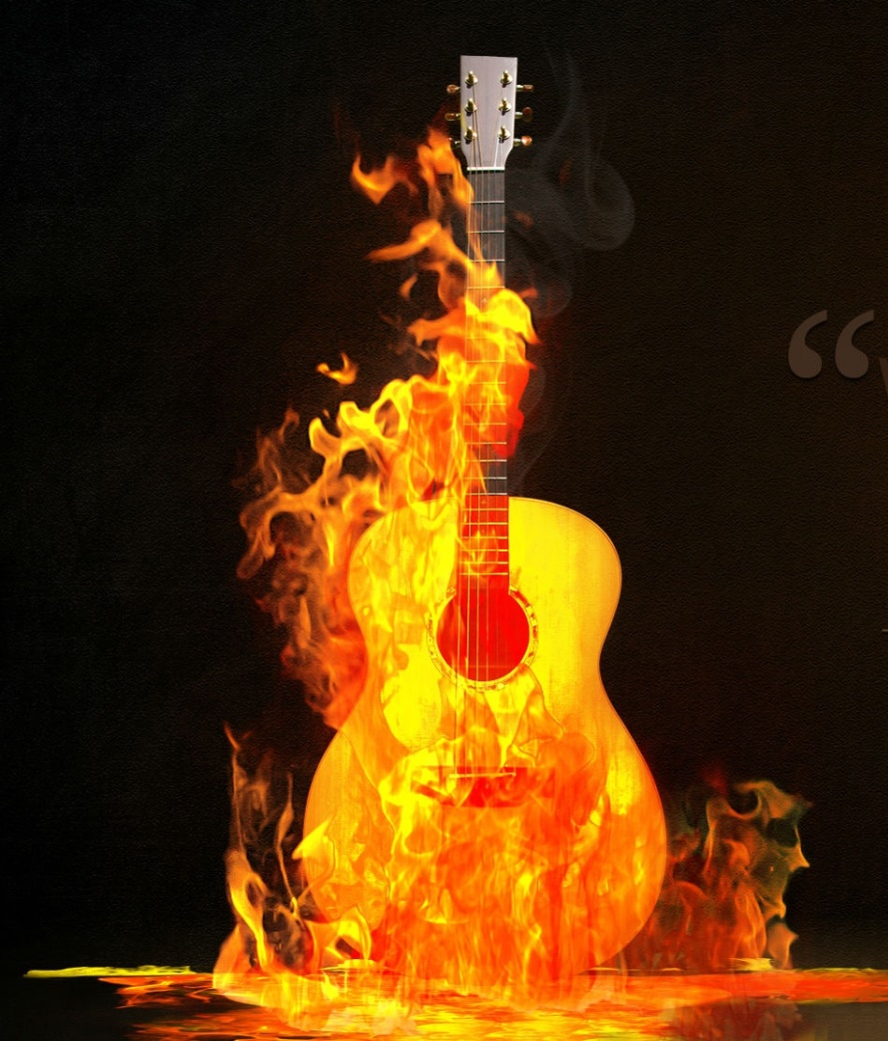
“Rock ‘til Midnight”

Outdoor Rock
Concert Featuring Five
Outstanding Rock Bands
with Headliner:
Imagination

Friday, October 15
River Coliseum
Rock & Roll House
Westmont, CA

Tickets available through most
Ticket outlets and at
Rock & Roll House:

In person: Welcome center
Phone: 323-555-1010
Online: rockrollhouse@trophe.com

House

